MODULE 1A PART A: STUDENT FACTSHEET – THE BEEF INDUSTRY

Beef accounts for 24% of the main meats that are produced in the World.
figure 1 world’s meat production 2009 (www.fao.org)

In 2009, 62.8 million tonnes of beef were produced by 202 countries across the World. Of these, 132 countries produced less than 100,000 tonnes and 11 countries produced more than 1,000,000 tonnes (Table 1). The 11 countries that produced more than 1,000,000 tonnes were responsible for 65.6% of the total produced (www.fao.org and faostat.fao.org ). Britain produced 849,860 tonnes in 2009.

Country | Million tonnes
Argentina | 3.4
Australia | 2.1
Brazil | 9.4
Canada | 1.3
China | 6.1
France | 1.5
Germany | 1.1
India | 1.1
Italy | 1.7
Mexico | 1.7
Russian Federation | 11.9
United States of America | 3.4
Table 1 : countries producing >1,000,000 tonnes of beef 2009
Between 2000-2009 there was an increase of 6.56 million tonnes or 11.7% in beef production in the World (), the United States of America, European Union, Brazil and China being the four main trading units. Although the production from the Rest of The World is substantial, it is a compound figure representing many countries that do not function as trading units.
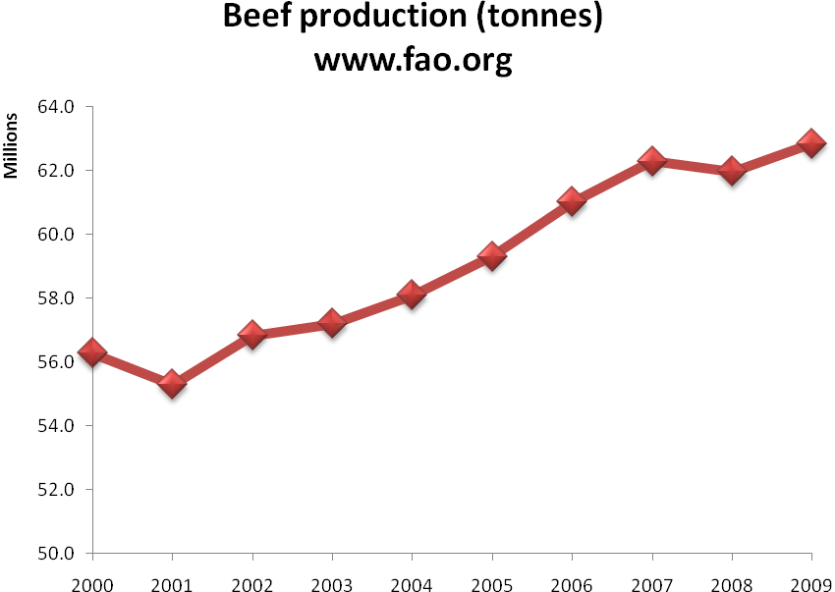
Figure 2 : world’s beef tonnage production

Brazil, China and the Rest of the World are responsible for the highest tonnage increase (Table 2). There was a decrease in production in the European Union and United States of America. China is responsible for 19.3%, Rest of the World 39.5% and Brazil for 42.9% of the increase across the World.
Trading Unit | % change in the beef tonnage production 2000-2009 | Change in the beef tonnage production 2000-2009 | % contribution to the total increase production across the World
Argentina | 24.3% | 660000 | 10.1%
Australia | 8.0% | 160010 | 2.4%
Brazil | 42.8% | 2816200 | 42.9%
China | 26.4% | 1265625 | 19.3%
USA | -3.3% | -406800 | -6.2%
European Union | -6.2% | -524834 | -8.0%
Rest of the World | 13.3% | 2592164 | 39.5%
The World | 11.7% | 6562365
Table 2 : world’s beef production changes 2000-2009
By 2009, the four main beef trading units were much closer together in size (Figure 3) compared to the year 2000 (Figure 4), with the United States of America still being the main producer, followed by the European Union, Brazil and China.
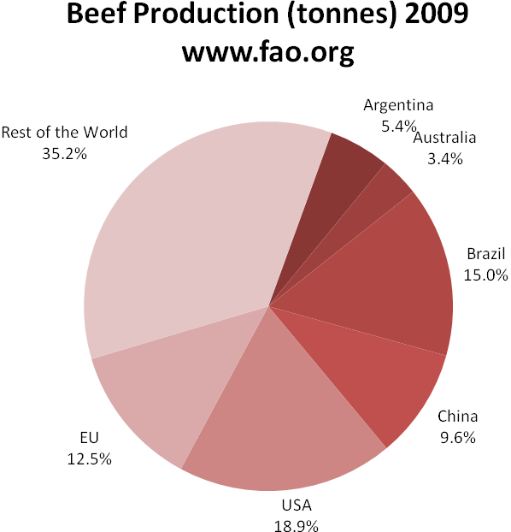

Figure 3 : distribution of the world’s beef production 2009
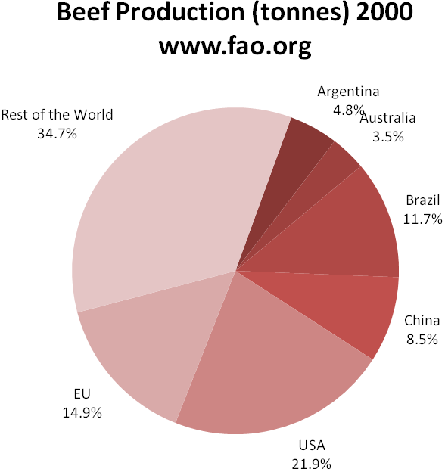
Figure 4 : distribution of the world’s beef production 2000

trade balance

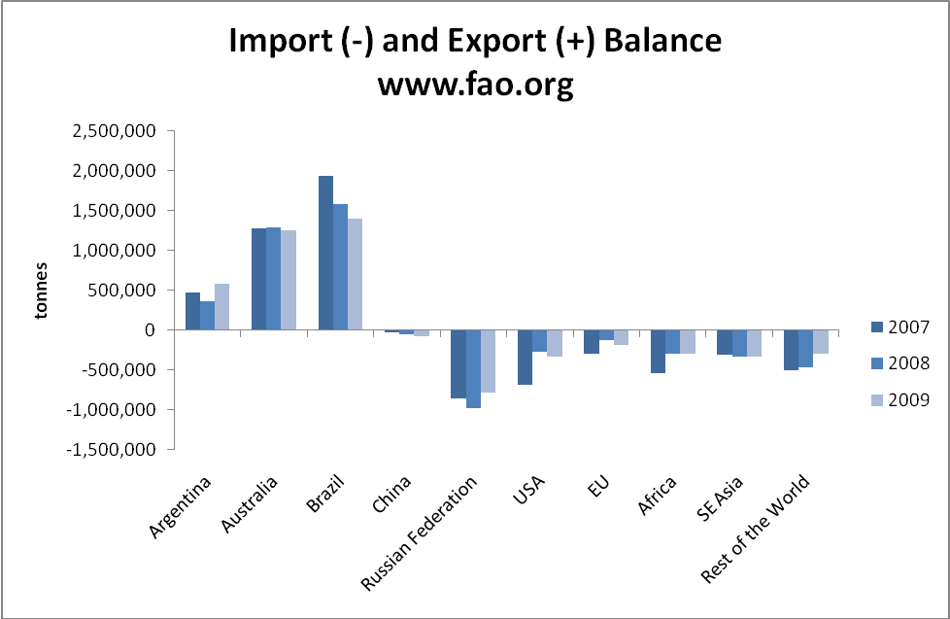
Figure 5 imports and exports balance
The main beef exporters in the world are Brazil, Australia and Argentina. China is more or less self sufficient, the European Union imports some meat while the Russian Federation, United States of America, Africa, South East Asia and the Rest of the World are substantial beef importers. Despite being a major beef producer the United States is also a significant beef importer.
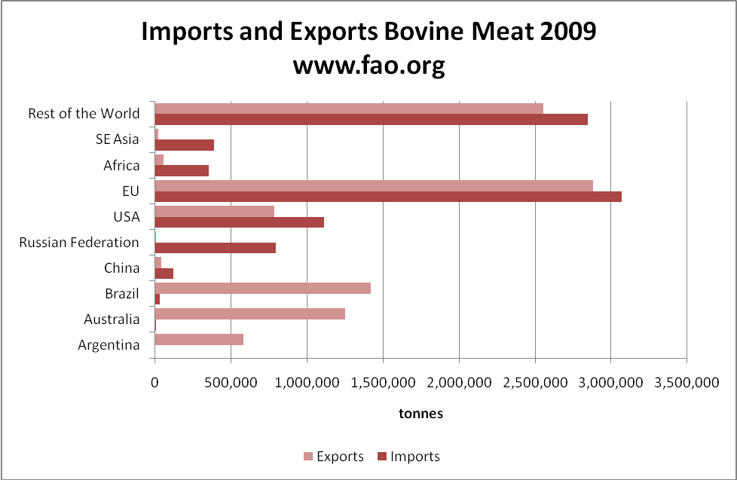
Figure 6 imports and exports 2009

Beef within the European Union
The European Union is one of the biggest beef trading units. Nevertheless, production is declining gradually, mainly because of the decreasing number of cows and the increasing feed costs. By 2014, it is expected that production will continue to decline and imports to increase.
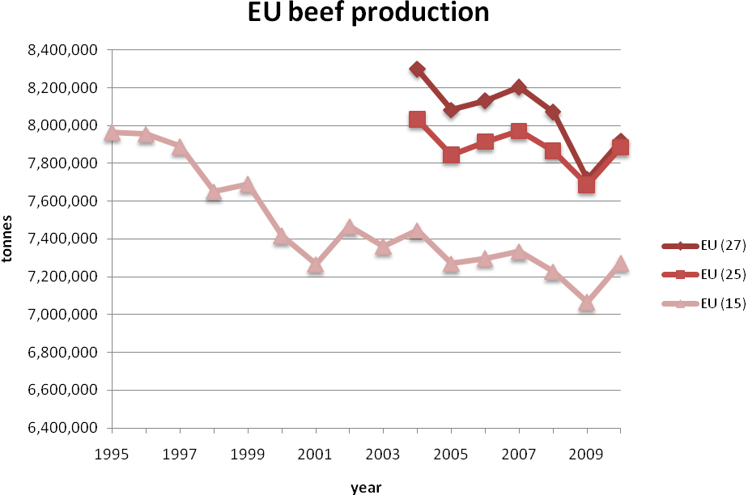
Figure 7 european union beef production

relevant web sites

www.fao.org
FAOSTAT http://faostat.fao.org/site/339/default.aspx
Eurostat http://epp.eurostat.ec.europa.eu/portal/page/portal/eurostat/home/

